Lab 8 – Forms and Session State

# Purpose

* Forms
* Various ‘input’ Tags
* Session State

# Due Date

* This lab is must be handed in:

**Sunday Mar 23, 2025 – before midnight**

# Assessment

* This Lab is worth 2% of your total course mark.

# Assigned Readings

* **Lecture Slides** posted on Brightspace
* Module 4 -> Part 1
* The following chapters of **Fundamentals of Web Development** will be useful in completing this exercise:
* Chapter 15

# Lab Supplies

To complete this lab you will require the following lab supplies:

* Lecture Slides (**Module 4 -> Part 1**) and Code Examples (**Form and Session State Code Examples.zip**) posted on Brightspace
* Textbook: **Fundamentals of Web Development** by Randy Connolly and Ricardo Hoar
* EasyPHP, or other WAMP server
* Eclipse, Notepad (or other text editor, or IDE)

# Summary of Tasks

1. Develop the logic to display your web application
2. View your webpage using a web browser
3. Submit Source Code of all PHP files on Brightspace

# Task 1

Implement the following Design Pattern to create a ‘Common Look and Feel’ to be used on every page of your website.

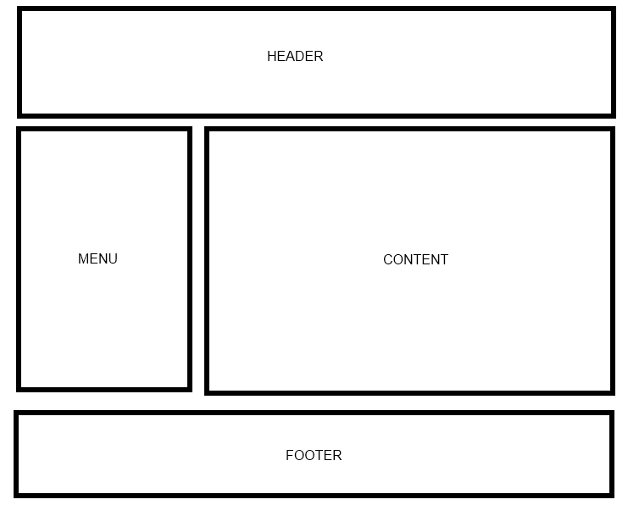

Your web site will include the following PHP scripts:

* Header.php
* Footer.php
* Menu.php
* Input.php
* Session1.php
* Session2.php

**NOTE: Input.php, Session1.php, Session2.php all must include the Common look and feel implemented in Header.php, Footer.php and Menu.php.**

**Header.php**

Header.php must contain a script to display a Common Header that will appear on every page. The header must display Program Name and Course Name.

**Footer.php**

Footer.php must contain a script to display a Common Footer that will appear on every page. The footer must contain Student Number, First Name, Last Name, and Email Address

**Menu.php**

Menu.php must contain a script to display a Common Menu to be show on every page. The menu must contain links to Input.php, Session1.php and Session2.php

**Input.php**

Create a PHP script that will perform the following tasks:

1. Divide the content area of this page into two sections (Side by Side)
2. On the left side: create a form that accepts the following information from the user
   1. Text box (input type="text"), First Name
   2. Text box (input type="text"), Last Name
   3. Text box (input type="number"), Telephone Number
   4. Text box (input type="email"), Email
   5. Text box (input type="date"), Birth Day
   6. Radio Button, with the values Student, Doctor, Farmer and Engineer
   7. Select, a select box that lists favorite sports (e.g., Hockey, Football, Carling, Tennis)
   8. Submit button with the text ‘Submit’
3. On the right side: When the user clicks ‘Submit’, it should gather all the information from the form on the left side and display the results on the right side.

Sample screenshot for ***Input.php*** is below:

|  |
| --- |
|  |

**Session1.php**

Create a PHP script that will perform the following tasks:

1. Implement the same form listed in **Input.php**
2. This time, when the user clicks ‘Submit’ , it should store all the information gathered from the form in the session state
3. Automatically Redirect the user to Session2.php

Sample screenshot for ***Session1.php*** is below:

|  |
| --- |
|  |

**Session2.php**

Once the user is forwarded to Session2.php, display the results of the information gathered from the session state of the form Session1.php.

Sample screenshot for ***Session2.php*** is below:

|  |
| --- |
|  |

**NOTE: Forms, Session_RetrieveValues.php, Session_StoreValues.php (Posted on Brightspace) provide examples of how to do all of these things.**

# Task 2

Create Lab 8 submission folder ‘**Lab8**’ and copy **Input.php, Session1.php, Session2.php, Header.php, Footer.php, Menu.php** and any other required files **(**e.g**. css file)** into this folder**.**

Create a **Lab8.zip** file by compressing the '**Lab8'** folder.

To hand in your lab go to Brightspace and navigate to Course Content 🡪 Labs.

Then click on ‘Lab 8 – Forms and Session State’ link.

Upload **Lab8.zip** on Brightspace.

**IMPORTANT NOTE**:

**You MUST demo the lab and explain the code to the Lab Professor to get marks.**